

In this demo, you will show how developers can use Open Liberty in **dev mode** for achieving efficient iterative develop, test, debug cycle when developing Java based applications / microservices. Liberty dev mode works the same with WebSphere Liberty.

At the end of this demo, you should be able to showcase how to:

* use Liberty **dev mode** with an Integrated Development Environment (IDE)
* use Liberty Code Assistant to change configurations of a Liberty server
* use Liberty Code Assistant to update Java application code
* run integrated unit tests from Liberty **dev mode**

**Open Liberty** is an application server designed for the cloud. It’s small, lightweight, and designed with modern cloud-native application development in mind.

Open Liberty supports the full MicroProfile and Jakarta EE APIs and is composable, meaning that you can use only the features that you need, keeping the server lightweight, which is great for microservices. It also deploys to every major cloud platform, including Docker, Kubernetes, and Cloud Foundry.

**Maven** is an automation build tool that provides an efficient way to develop Java applications.

Liberty **development mode**, or **dev mode**, allows developers to develop applications with any text editor or IDE by providing hot reload and deployment, on demand testing, and debugger support. Liberty **dev mode** is enabled through **Maven** and **Gradle** projects.

With Liberty **dev mode**, the application code is automatically compiled and deployed to the running server, making it easy to iterate on the code changes.

Developers can run tests on demand or even automatically so that you can get immediate feedback on their changes. They can also attach a debugger at any time to debug their running application.

**Visual Studio Code** (VS Code) is a code editor redefined and optimized for building and debugging modern web and cloud applications. VS Code is the IDE used in this Demo environment.

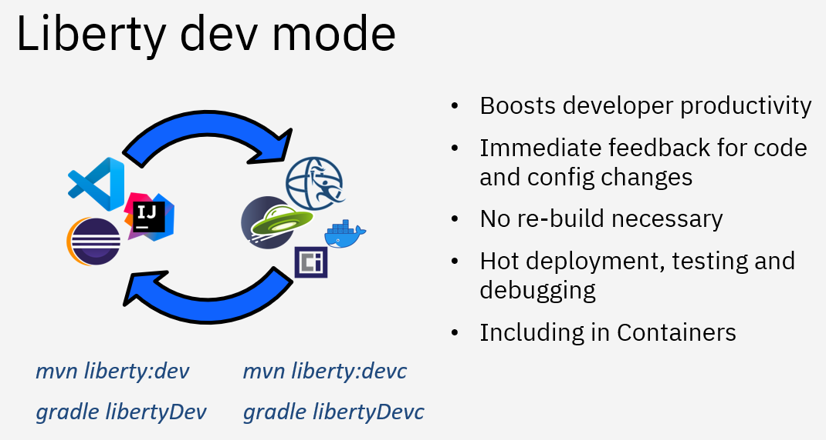

This demo has the following steps:

1. Create a Liberty web application
2. Update the Liberty web application
3. Run Liberty **dev mode** using integrated development environment
4. Update Liberty server configuration with Liberty Code Assistant
5. Modify application code with Liberty Code Assistant
6. Conduct a unit test in Liberty **dev mode**
7. Summary
8. Create a Liberty web application.

**Talking Points**

The objective of this step is to develop a simple web application for Liberty. I will use a Liberty starter application to start from scratch and use VS Code and Liberty Tools to build the application. I will create a Jakarta EE 10 Web application with the name whereamI and will use maven to build it.

The fastest way to get started with Liberty is to use an Open Liberty starter application which generates a project with the maven configuration as well as a basic Liberty setup.

The Open Liberty starter gives us a simple, quick way to get the necessary files to start building an application on Open Liberty. There is no need to search how to find out what to add to our maven or gradle build files. A simple RestApplication.java file is generated for us to start creating a REST based application. A server.xml configuration file is provided with the necessary features for the MicroProfile and Jakarta EE versions that we selected.

1. Open a browser window by clicking on **Activities** (A) and then select the **Firefox** browser icon (B).

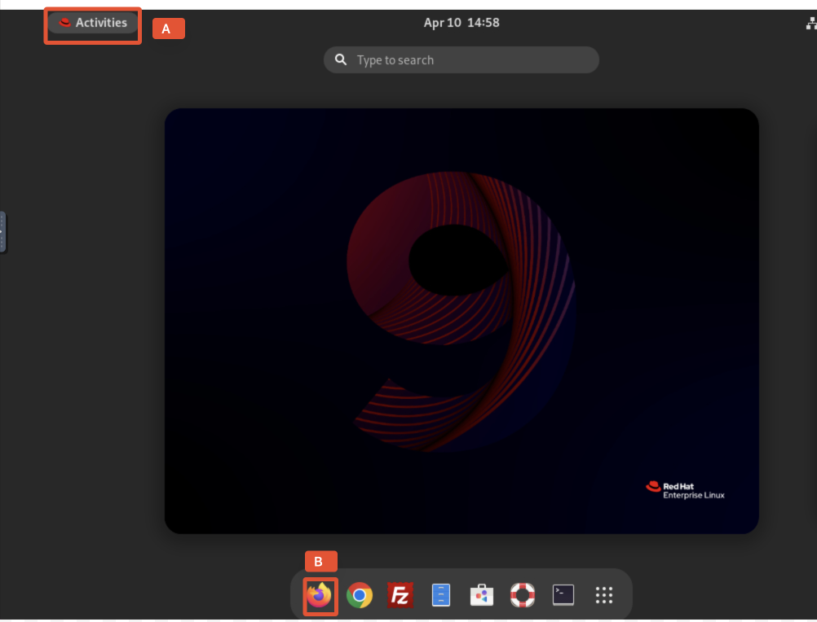

1. Enter the URL **https://openliberty.io/start/.**

**The Open Liberty Starter page is displayed.**

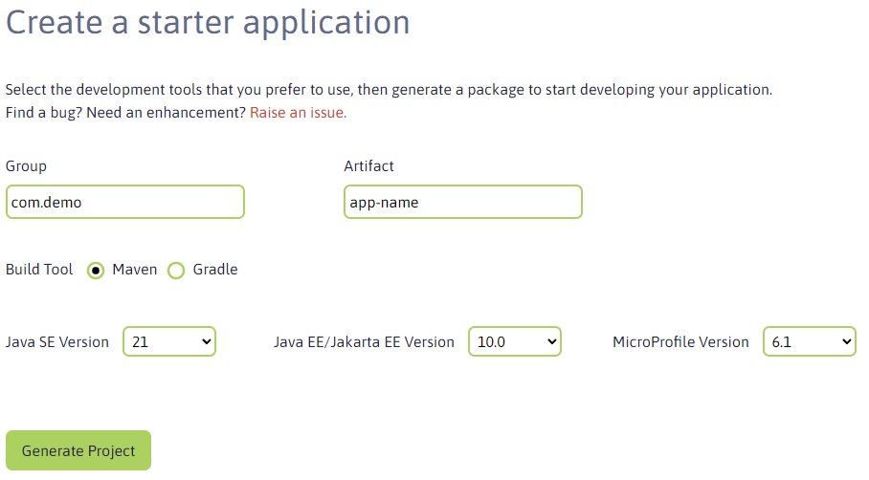

1. Change the artifact name to **whereami** (A), change the Java level to **17** (B) and leave the rest as is, then click **Generate project (C).**

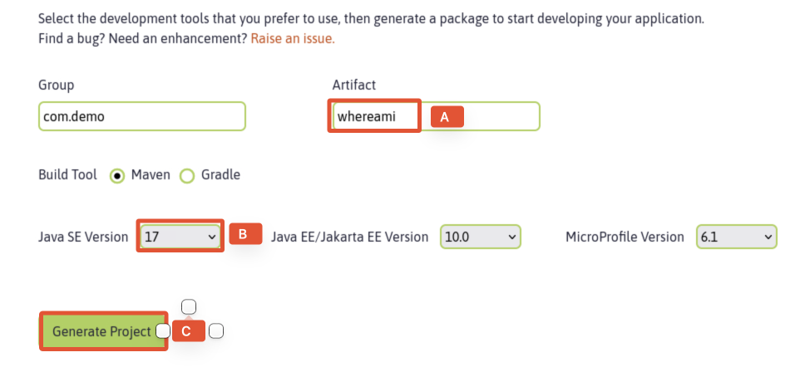

1. Click on **Save** (A) to save the project under **Downloads** directory of the **Demo** VM.

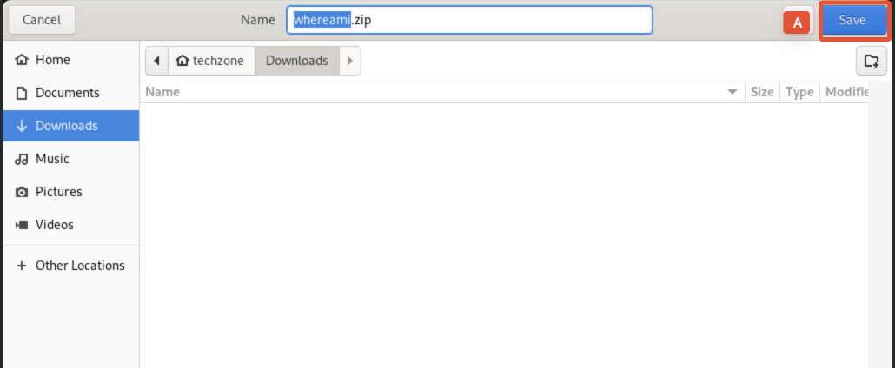

You will see a pop-up like the one below. Click on **Got it!**  (A) to close the window.

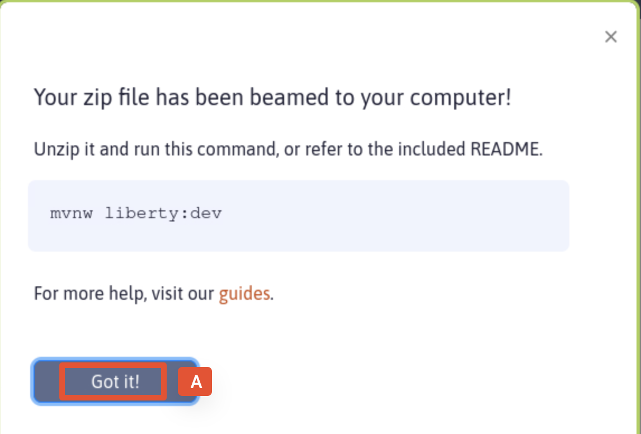

1. Click **Activities** (A) and switch to the terminal window (B).

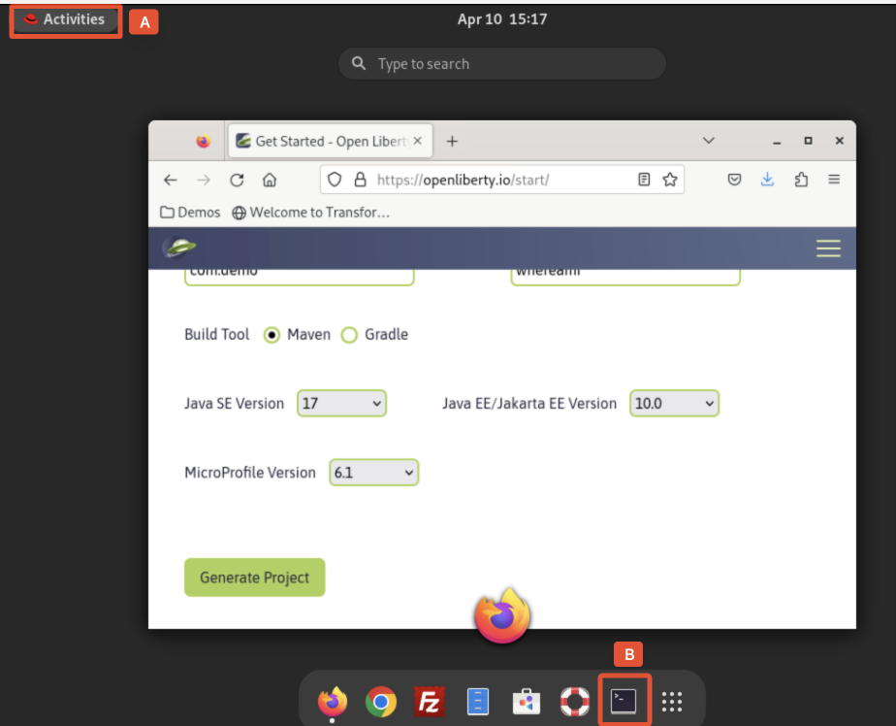

1. From the terminal window, extract the project zip file to the working directory with the following commands.

mkdir ~/Student

unzip ~/Downloads/whereami.zip -d ~/Student/whereami

The project is extracted to the **~/Student/whereami** directory.

1. Inspect the **whereami** project artifacts and sour code files created by Open Liberty Stater Application using commands:

Ls -l ~/Student/whereami

The **whereami** project artifacts and sour code files are listed.

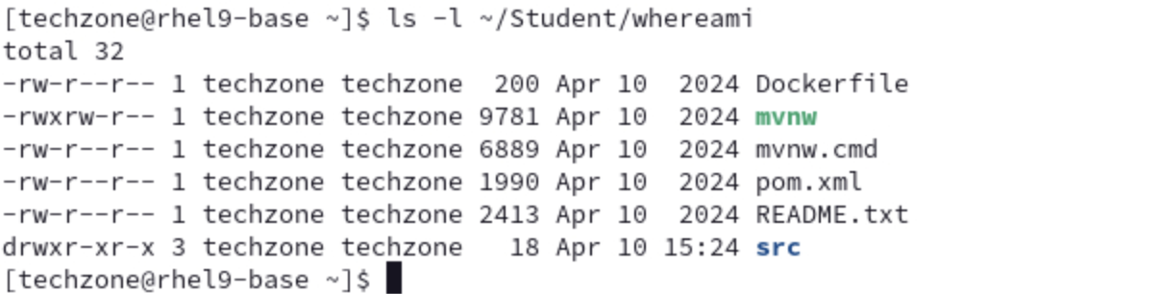

As we can see, the Open Liberty Stater Application creates the project structure and basic files needed for the project. The next step is to add application functions and business logic to the project.

1. Update the **whereami** application.

**Talking Points**

In this step, we are going add application functions and business logic to the **whereami** application. To save time, I am going using the pre-built application code I get from my GitHub repo.

1. Replace the **whereami** application code in Student directory with the pre-built code from the GitHub repo with command:

cp -rf ~/Downloads/whereami-with-tests/whereami/ ~/Student/

1. Check and test **whereami** application in VS Code with commands:

cd ~/Student/whereami

code .

The VS Code UI will be opened.

1. Click on **Yes, I trust the authors** (A) to continue.

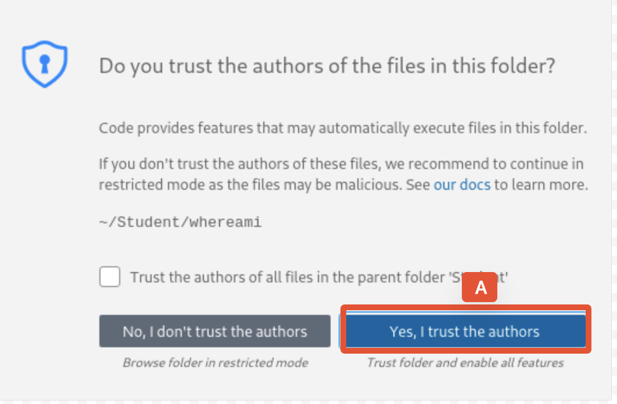

If you see during the lab one of the pop-ups below or any other pop-up asking to install something, close the pop-up without installation by clicking the **X** (A).

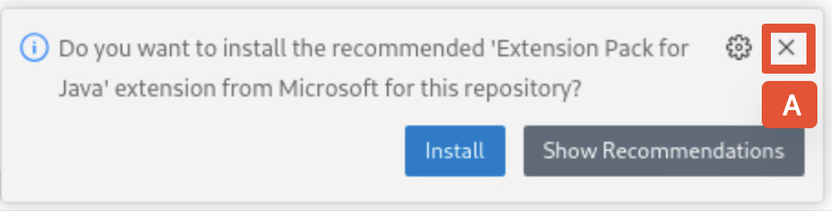

When the project loaded, we can see that we added the WhereAmI.java file as well as a unit test in the project.

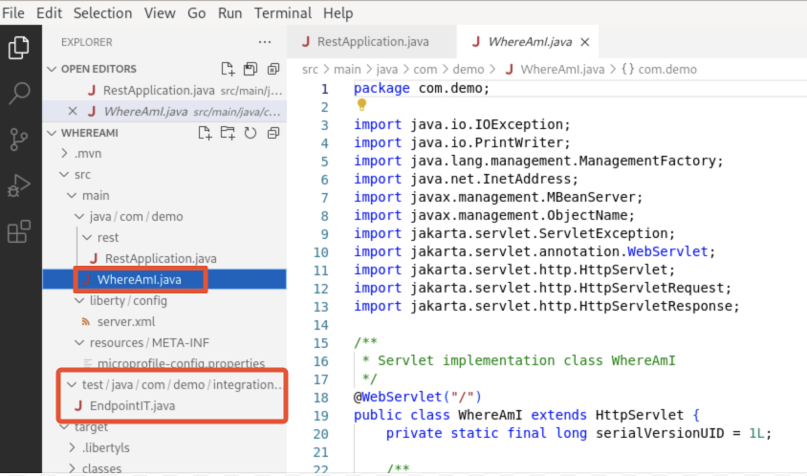

We also configured the Liberty server with all features needed for the application.

1. Start Liberty Dev Mod.

**Talking Points**

Liberty development mode, or dev mode, allows us to develop applications with any text editor or IDE by providing hot reload and deployment, on demand testing, and debugger support. Liberty Dev Mode is enabled through Maven and Gradle projects.

Our code is automatically compiled and deployed to our running server, making it easy to iterate on your changes.

We can run tests on demand or even automatically so that you can get immediate feedback on our changes. We can also attach a debugger at any time to debug our running application.

We can use the capabilities of Liberty dev mode inside and outside of an IDE. This provides us the flexibility of choice. In a terminal window, we would use Liberty in dev mode with maven using the command **mvn liberty:dev** or **mvn liberty:devc** if we want to develop in a container.

In the Demo environment, the Liberty tools plugin has been installed into VS Code. Therefore we will use the integrated Liberty dashboard instead.

We will show how to run Liberty dev mode in VS Code and how to use the Open Liberty Tools in VS Code to work with our server configuration, application code and run integrated unit tests on demand, so that we can get immediate feedback on our changes.

In the VS Code environment, we right-click project under **LIBERTY DASHBOARD** and select start. This will start Liberty in dev mode and we will see the following message in the VS Code terminal window: Web application available (default_host): http://localhost:9080/wherami/. We can access the application URL in the browser window to verify that the application is running.

1. To start Liberty in Dev Mode right-click **whereami** under **LIBERTY DASHBOARD** (A) and select **Start** (B).

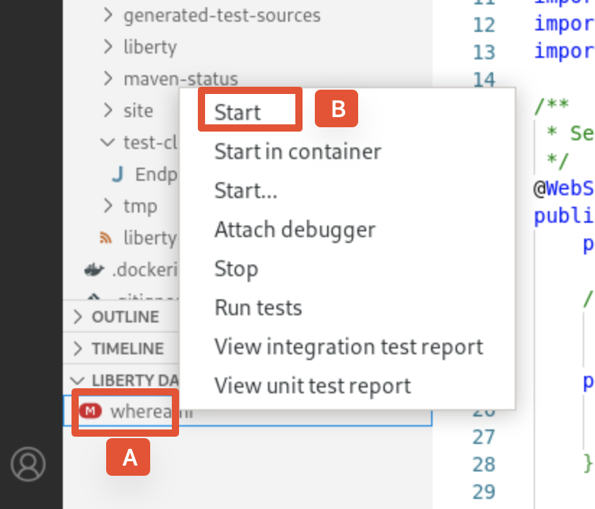

In a few sends, the Liberty server will be up and running, we can see that the **whereami** application is ready.

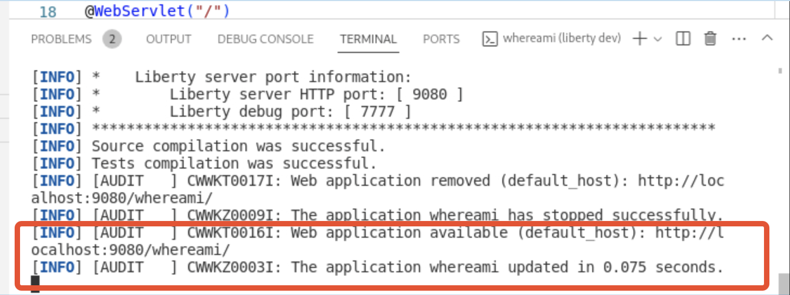

1. To access the **whereami** application, open a web browser and enter the application URL as: http://localhost:9080/whereami/.

The application page is displayed.

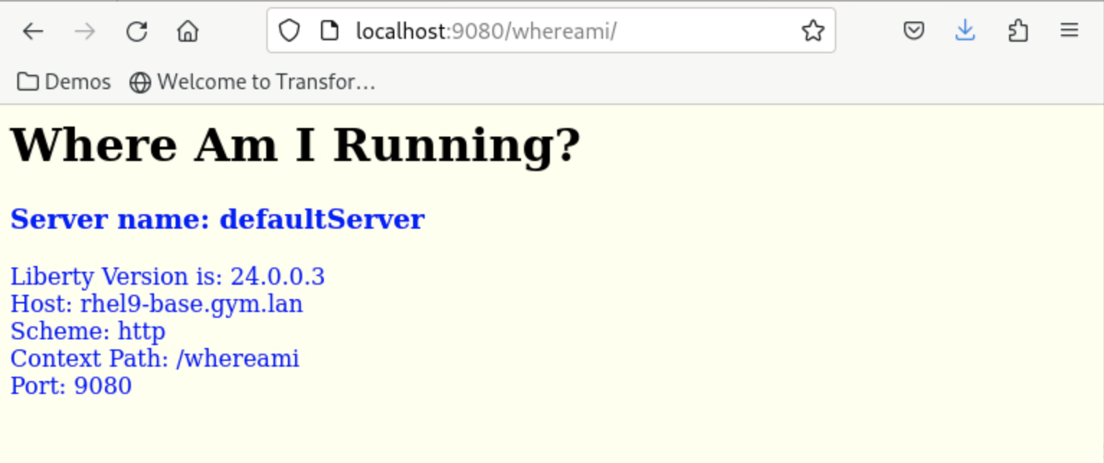

It lists the information about Liberty version used, the host name, scheme, context path and port.

1. Update Liberty server configuration with Liberty Code Assistant.

**Talking Points**

Now we are going to make changes to the Liberty server configuration and enable the server https port and we are going to use Liberty code assistant to speed up the server configuration process.

In order to active the https port of the Liberty server, we need to add the transport security feature the Liberty server and we can do it with Liberty code assistant.

I will demonstrate that I can update Liberty server configuration using Liberty code assistant and activate the https protocol without stop or restart the Liberty server.

1. In the VS Code environment, click to open the Liberty server configuration file **server.xml** under **target/liberty/wlp//usr/server/defaultServer** (A).

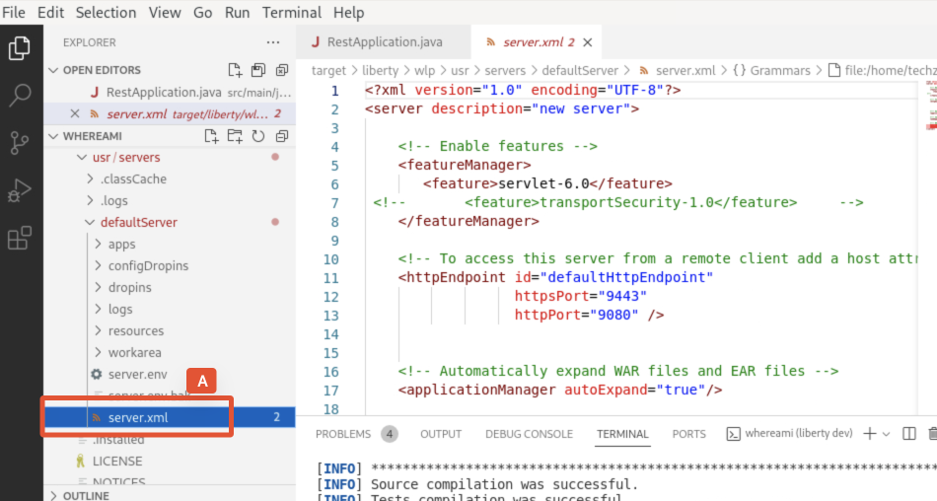

We can see that the https port is set as 9443.

1. If we try to access the application from the browser window using the https port as: https://localhost:9443/whereami/ (A), we will get the **Unable to connect** error because although the https port value is defined, the https port is not activated on the Liberty server yet.

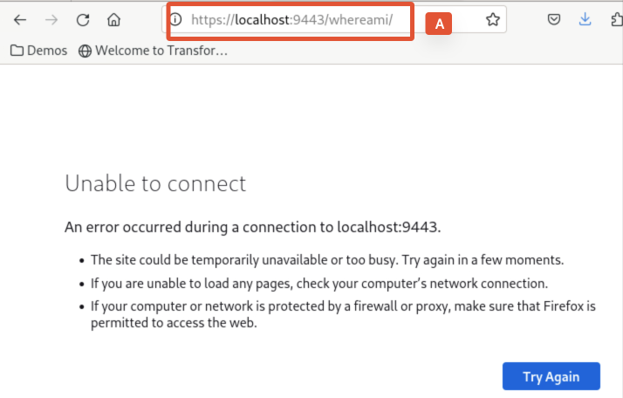

1. Back to VS Code, add a new line after <feature>servlet-6.0</feature> in the server.xml file (A), and activate the Liberty code assistant by pressing **CTRL+SPACE,** the code assistance window is shown.

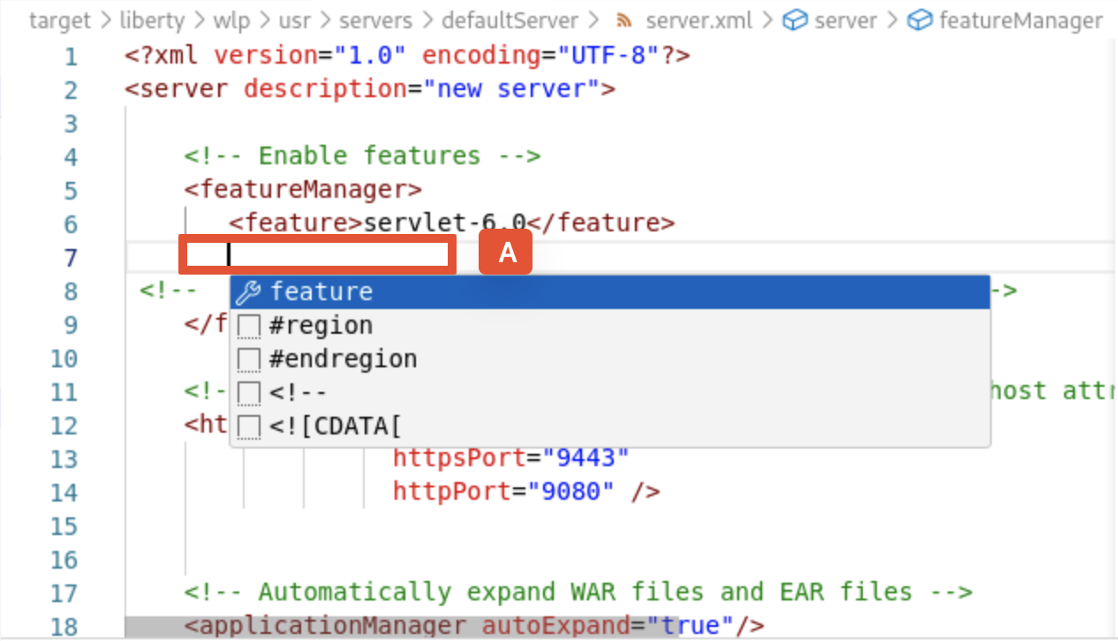

1. Select **feature** from the code assistant window (A). to add a new feature element.

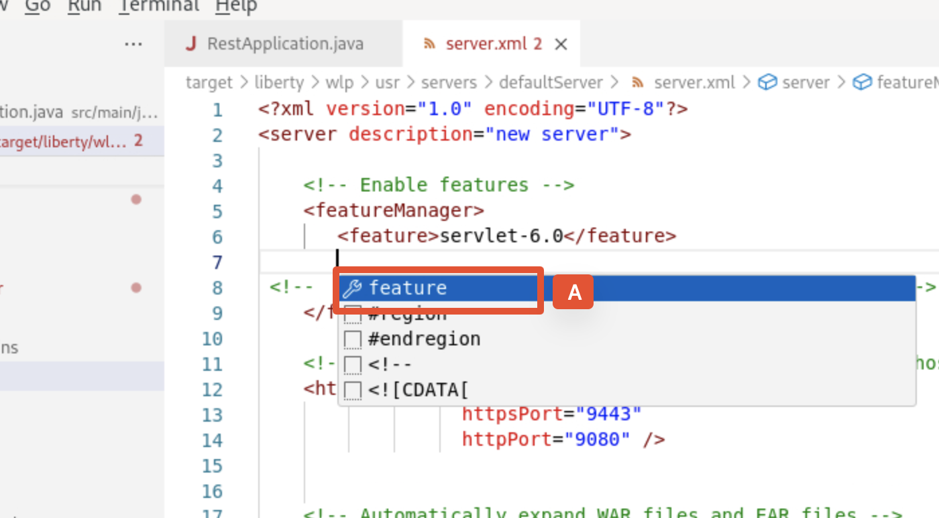

This will add a new feature element to the file.

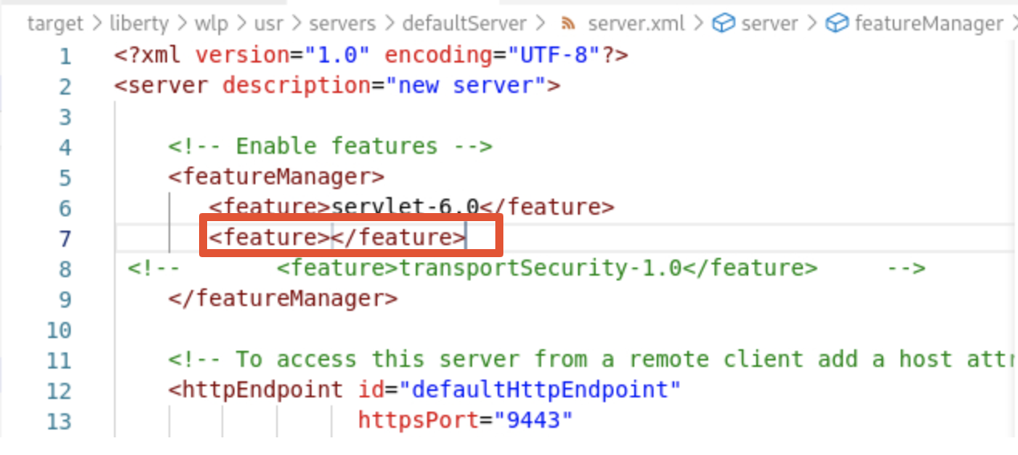

1. Type **tr** in the feature field, the code assistant will offer the feature names containing the word **tr**. Select the **transportSecurity-1.0** to add the feature.

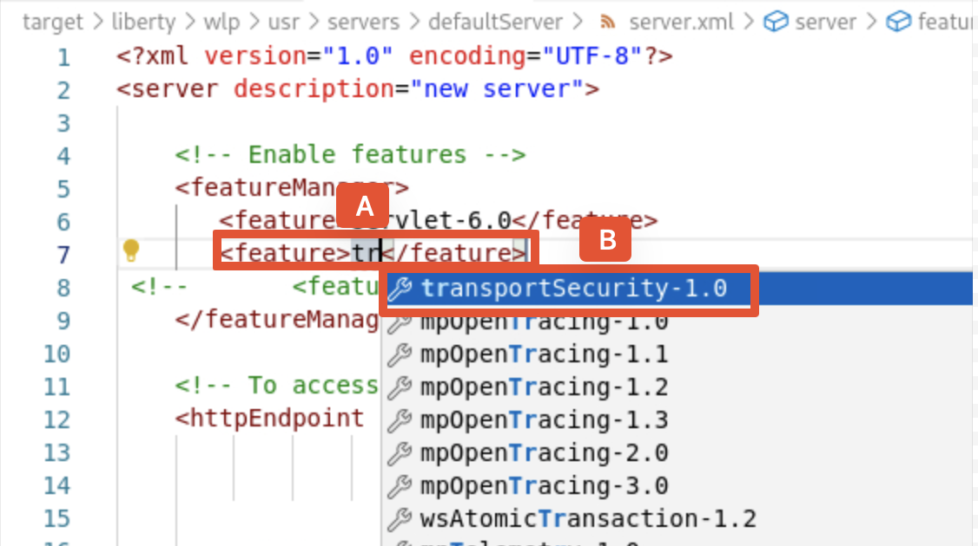

As we can see that in Liberty Dev Mod, once the new feature is added, the server configuration is dynamically updated. Liberty code assistant automatically detects that the **transportSecurity-1.0** feature requires the **ssl-1.0** feature, so it adds the **ssl-1.0** feature to the Liberty server configuration as well.

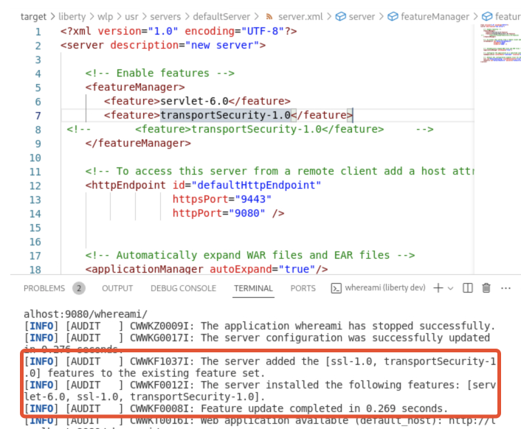

1. Now the https port is activated, if we try again to access the application from the browser window using the https port as: https://localhost:9443/whereami/ and accept the warning messages, we will get the application page.

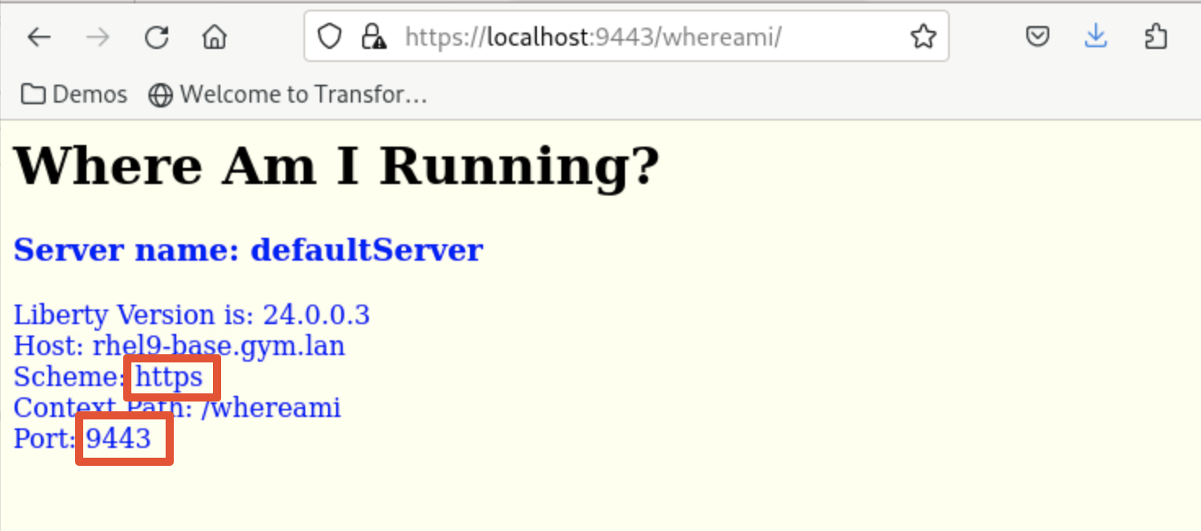

We can see now the protocol scheme is https and the port is 9443 which means that the https protocol is activated.

This demonstrates that using Liberty code assistance we can modify Liberty server configuration without restart the server.

1. Modify application code with Liberty Code Assistant.

**Talking Points**

In previous section, I shown how to use Liberty code assistance to update the Liberty server configuration. Now I am going to use Liberty code assistant to make quick modifications to the application code. I will make code modifications to change the color of the text showing on the application page for different network protocols. I will have the red color for http protocol and the green color for https protocol. I will show how easy it is to make change the application code with the help of Liberty Code Assistant in Liberty Dev Mod.

1. In the VS Code environment, click to open the servlet java file **WhereAmI.java** under **src/main/java/com/demo** (A).

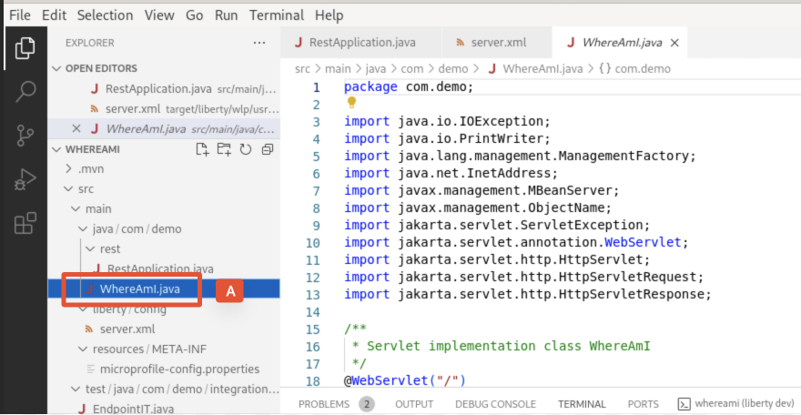

1. Scroll down to line 45 (A) and create a new line in the file (B).

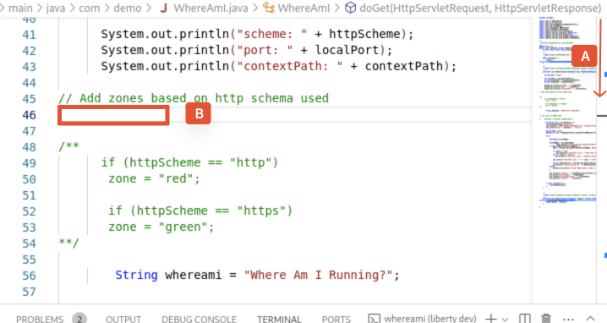

1. Type **i** (A) and use Liberty code assistant (**CTRL+SPACE**) to select **if statement** (B).

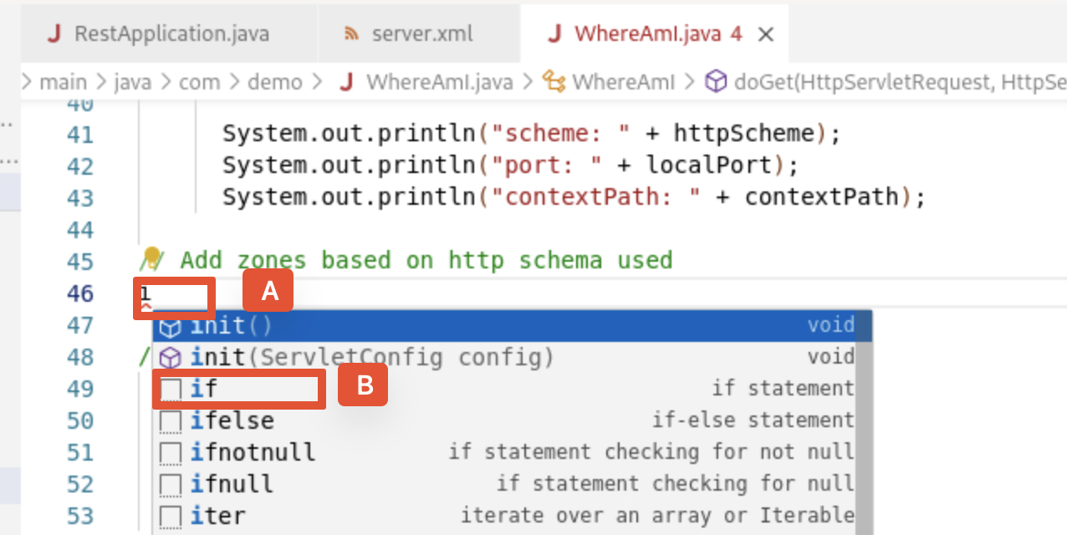

1. Highlight condtion:var(boolean) (A), press **CTRL+SPACE** and select **httpScheme** (B).

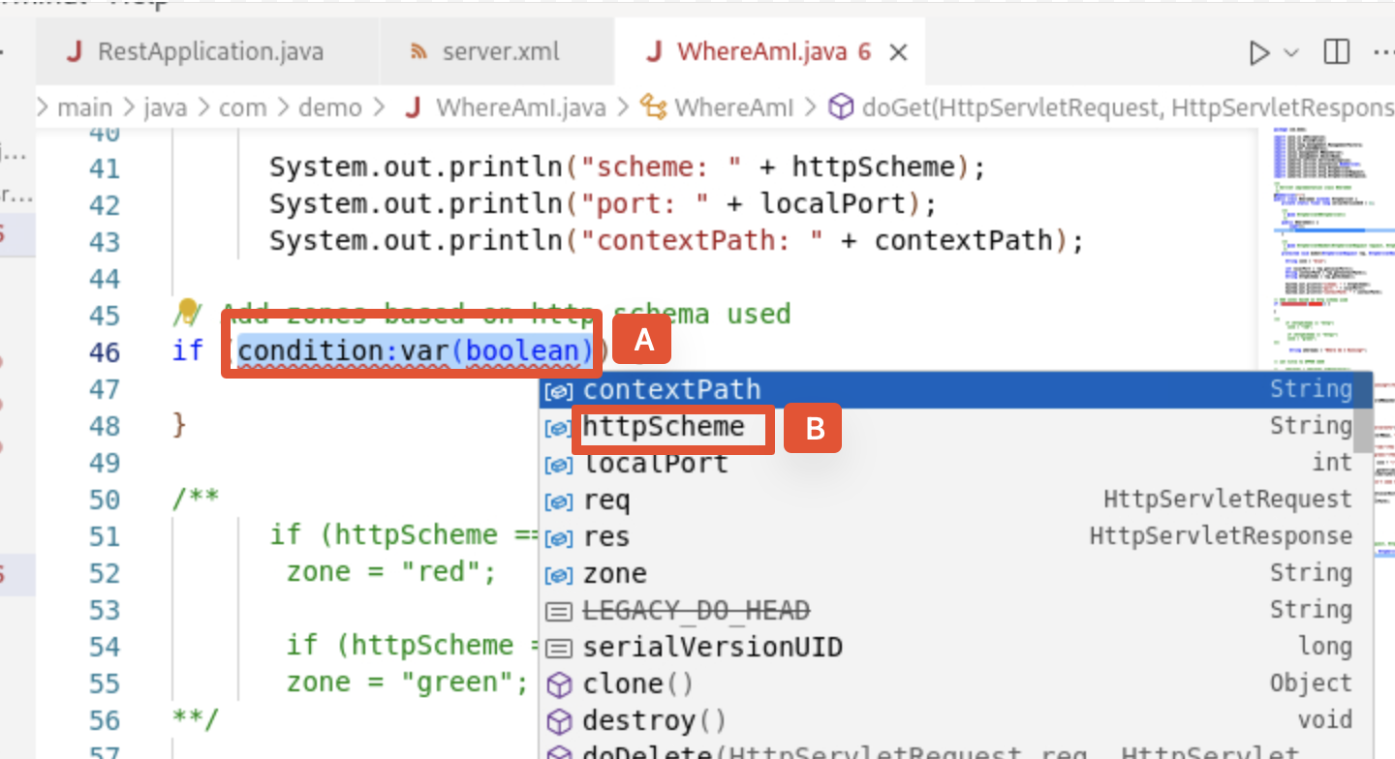

1. Type **==** "**http**" next to **httpScheme** (A).

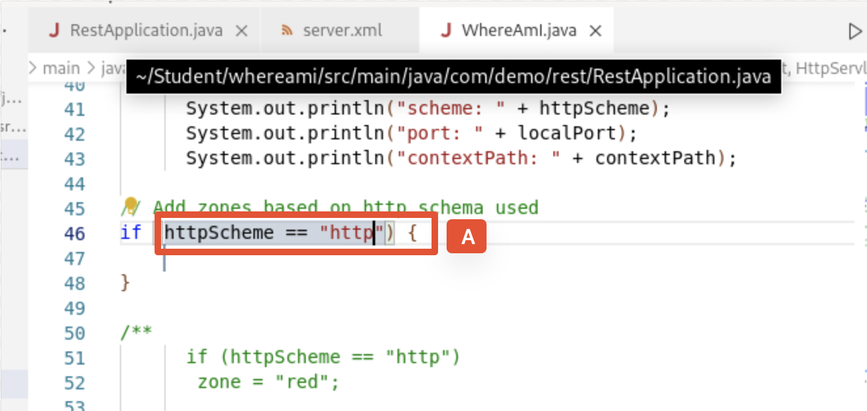

1. Move to the next line (A), press **CTRL+SPACE,** and select **zone** (B).

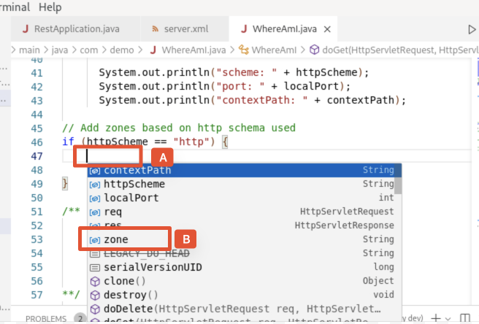

1. Type **=** "**red**"**;** next to the zone (A).

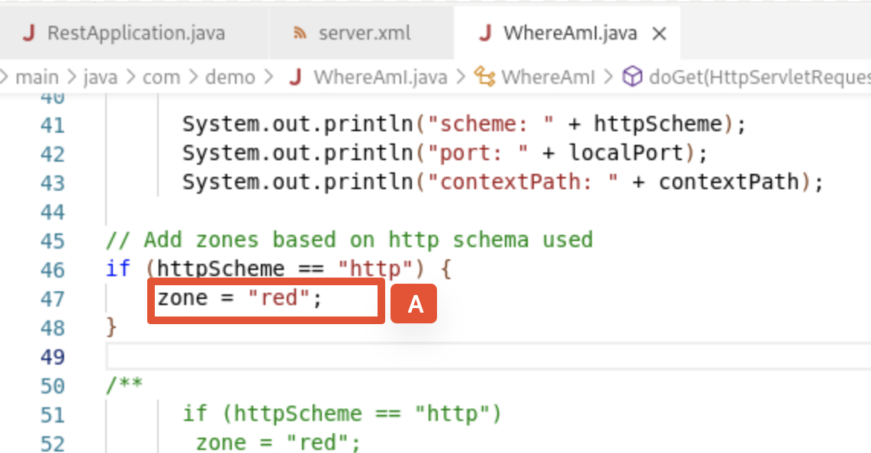

1. Repeat the same process to add another if statement like this:

if (httpScheme == "https") {

zone = "green";

}

We should see the application code we add as:

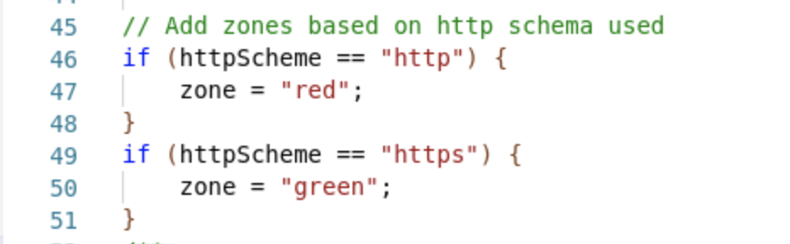

1. To verify the code changes, we can access the application page in the browser window with both http and https ports, we can see the changes we made to the application.

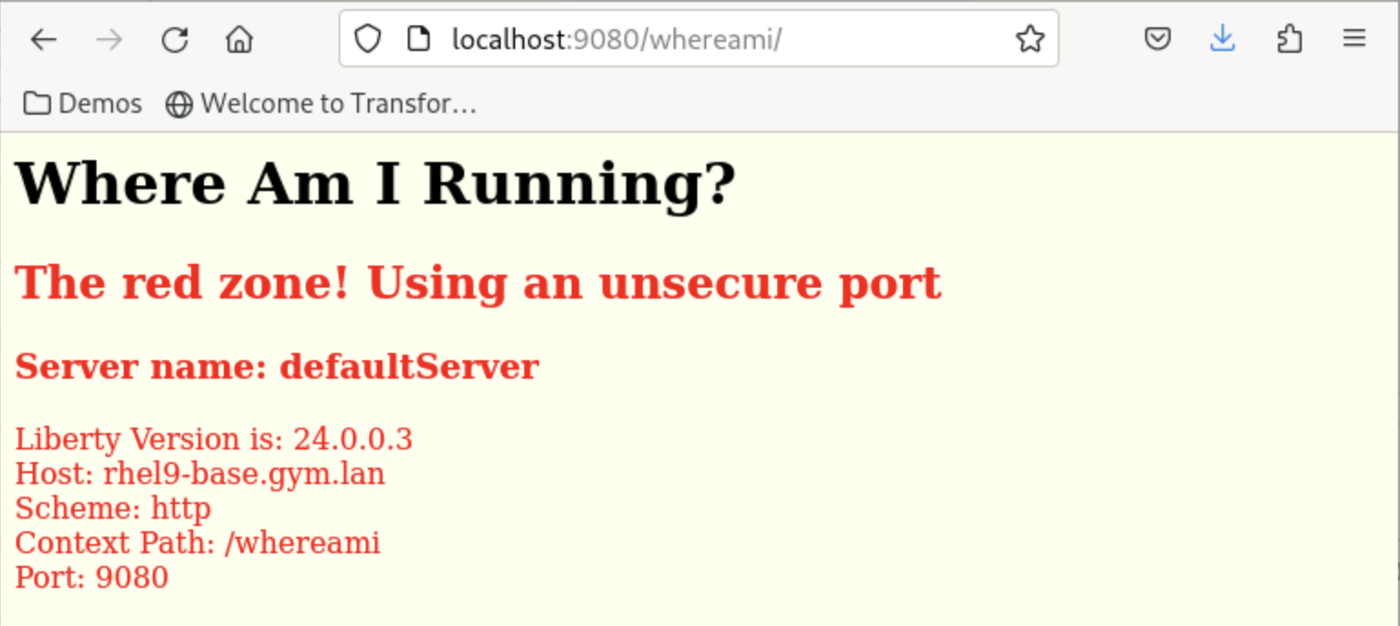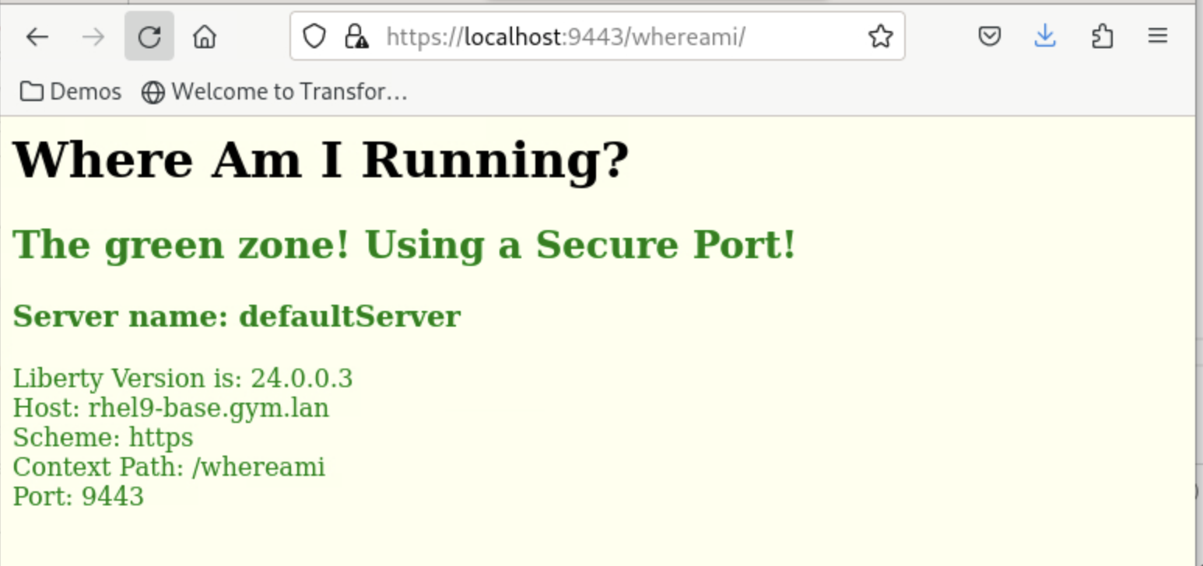

As we can see that when I made changes to my code, the changes were automatically saved and Liberty server adopted these new changes dynamically without re-starting. So as a developer, I can quick change, test and verify my application code.

1. Conduct a unit test in Liberty **dev mode.**

**Talking Points**

With Liberty Dev Mod, it is easy to conduct a unit test in the IDE. Within the IDE, we can run the unit test and integration test by right-clicking project under LIBERTY DEV DASHBOARD and select run test. This will active the test run and show the test results in the VS Code terminal window. Another way to activate the unit test is to press the **Enter** key n the VS Code terminal window.

In this section I will show how to do a unit test. The test is designed to check if the title of the application is in capital letters or not. It will be successful if the title of the application is in capital letters, otherwise it will fail.

By default, the title of the application is not in all capital letters, so our unit test will fail and provide information about where the issue is and how to fix it. Based the information, we will fix the error and run the test again, the unit test will be a success after the code fixing. I will demonstrate how the Liberty Code Assistant and Liberty Dev Mod can help speed up the unit test process.

As we know from previous section, the title of the application, **Where Am I Running?**, is not all in capital letters as shown below:



So our unite test will not going to be successful as expected.

1. From the VS Code environment, go to the terminal window (A) and press **Enter**.

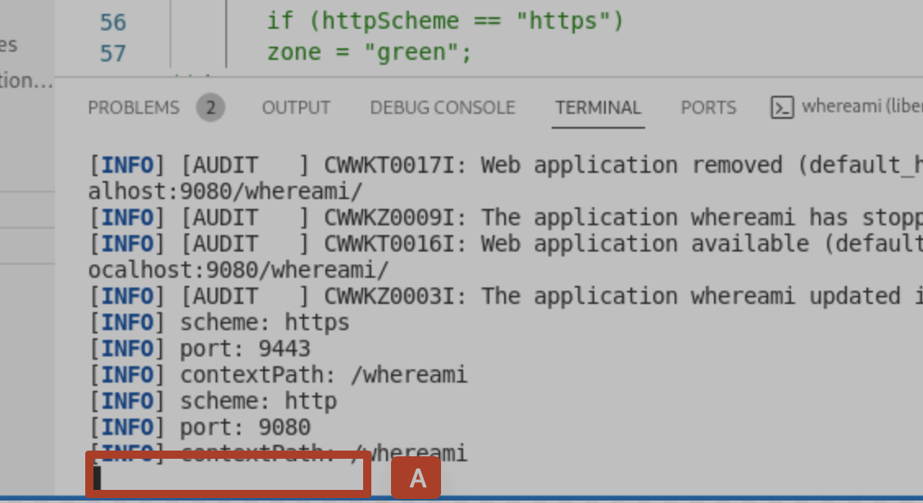

This will activate the unit test and integration test. We will see that the tests will fail with the message: **FAIL! ---> The header is in ‘lower case’!.**

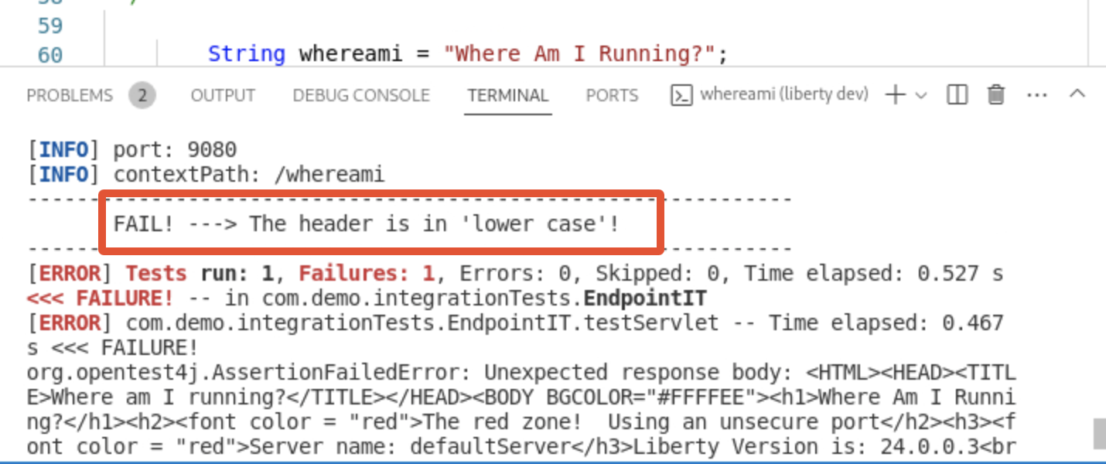

1. To fix the error, we need to update our code. Go back to WhereAmI.java file in VS Code, scroll down (A) and go to the line 64 (B).

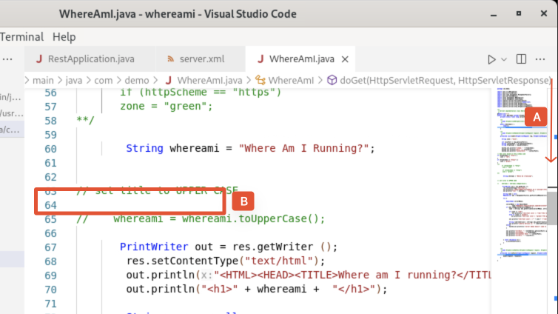

1. Type **w** (A) in the new line and use Liberty code assistant (**CTRL+SPACE**) to select **whereami** (B).

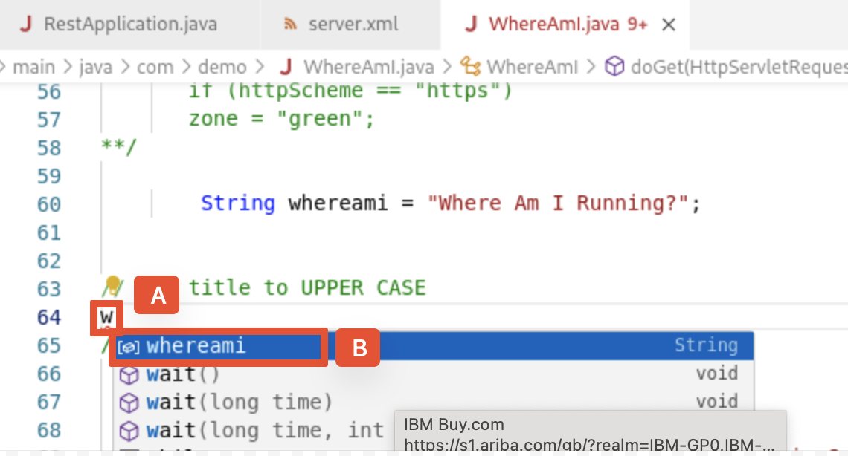

1. Type **=** after **whereami** (A), press **CTRL+SPACE** and select **whereami** (B).

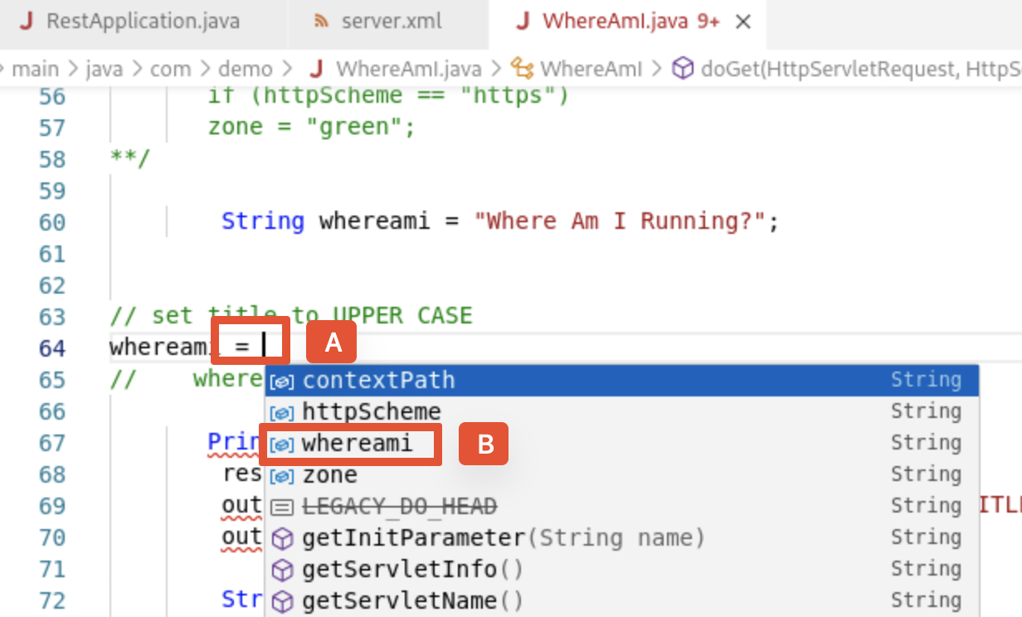

1. Type **.u** after **wherami** (A) and select **toUpperCase()** (B).

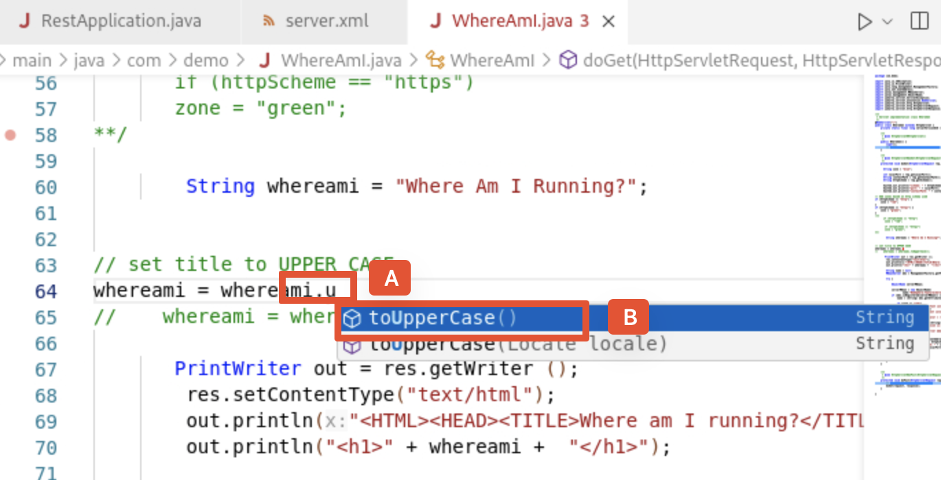

1. Type **;** in the end (A) and the code change will look like this:

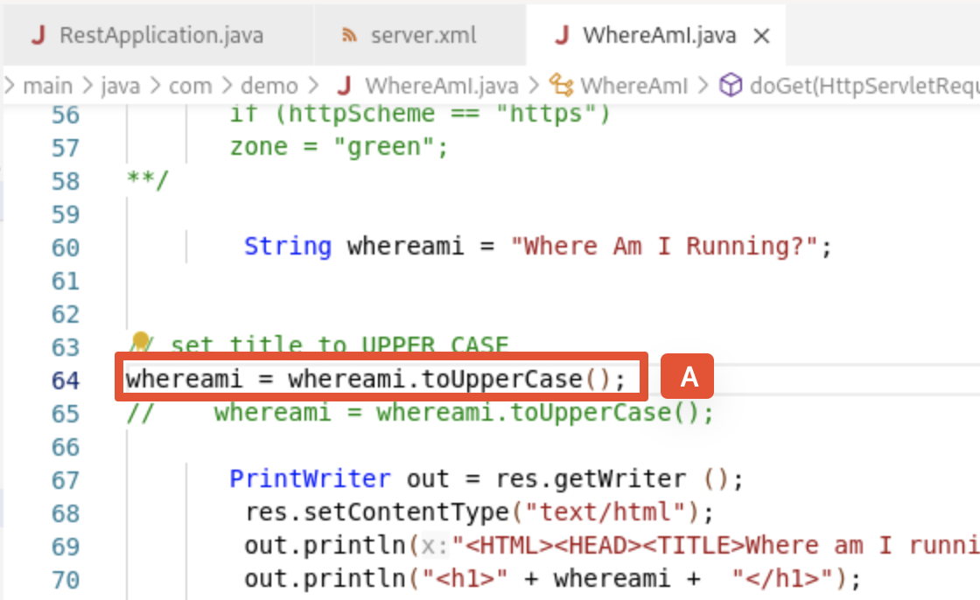

1. New let’s go back to run our unite test again from the VS Code terminal window by pressing **Enter** (A).

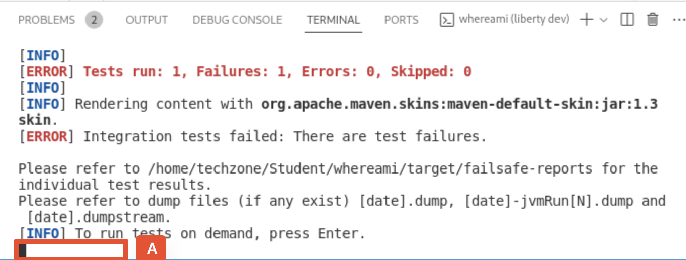

We will see that the unit test and integration test are successful with the message: **PASS ! ---> The head has been converted to UPPER CASE!**.

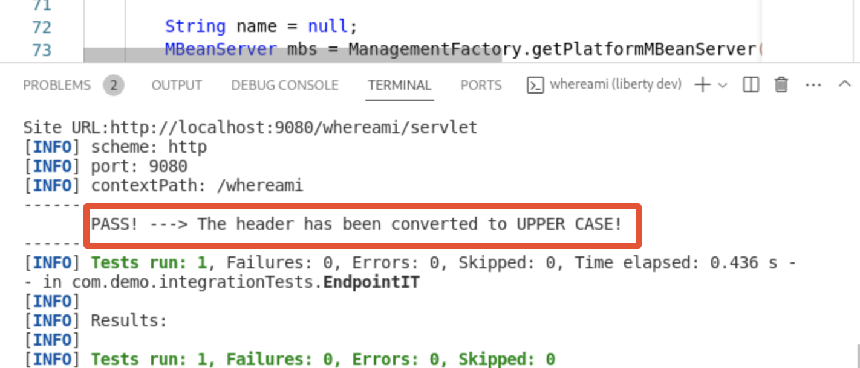

1. We can verify it in the **whereami** application at http://localhost:9080/whereami/.

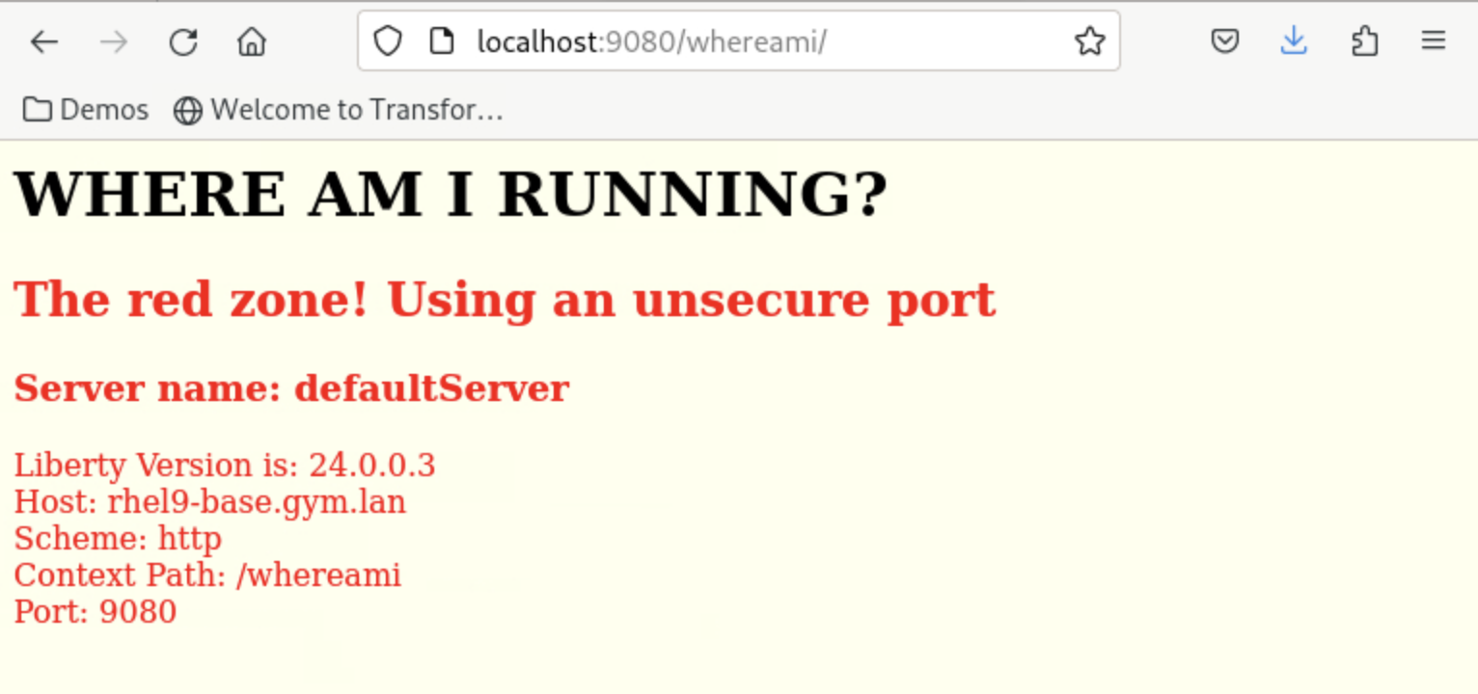

We can see that the change is made to the application title.

1. Summary

In this demo, we learned how developers can use Liberty in **dev mode** for achieving efficient iterative develop, test, debug cycle when developing Java based applications / microservices. As we explored the fast and efficient inner-loop development experience using the Liberty **dev mode** and **VS Code** IDE, our code was automatically compiled and deployed to our running server, making it easy to iterate on our changes.